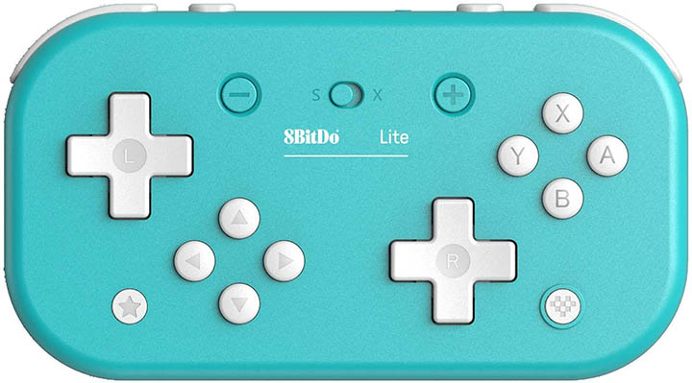

Konami-Code Instrument (KoCo)

Diatonic, (monophonic?) instrument. Converts buttons presses (holds?) to MIDI and outputs to VSTs.

L/R D-Pads are paired, C-Pads and Letters are paired

Hold L = Flat
Hold R = Sharp

L2 = Down 8va
R2 = Up 8va

